**PIZZA SQL QUERIES**

**A.KPI**

**1. Total Revenue**

SELECT SUM(total_price) FROM pizza_sales



**2. Average Order Value**

SELECT SUM(total_price) / COUNT(DISTINCT order_id) AS Avg_Order_Value from pizza_sales

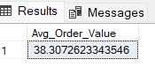

**3. Total Pizza Sold**

SELECT SUM(quantity) AS Total_Pizza_Sold from pizza_sales

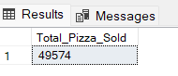

**4. Total Orders Placed**

SELECT COUNT(DISTINCT order_id) AS Total_Orders_Placed from pizza_sales

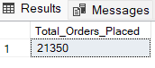

**5. AVERAGE PIZZAS PER ORDER**

SELECT CAST (CAST (SUM(quantity) AS DECIMAL (10,2)) /

CAST(COUNT(DISTINCT order_id) AS DECIMAL (10,2)) AS DECIMAL (10,2)) AS Avg_Pizza_per_order From pizza_sales

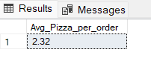

**B.CHARTS REQUIREMENT**

**1. Daily Trend for Total Orders**

We will have to find the daily trend on the daily basis which includes the days of the week (Mon – Sun).

DW is Day of the week. Always group by when using Aggregate Function.

SELECT DATENAME(DW, order_date) AS Order_Day, COUNT(DISTINCT order_id) AS Total_Orders From pizza_sales

GROUP BY DATENAME(DW, order_date)

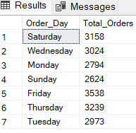

**2. Monthly Trend for Total Orders**

If you want to view the orders list in Descending order, use ORDER BY Function

SELECT DATENAME(MONTH, order_date) AS Month, COUNT(DISTINCT order_id) AS Total_Orders FROM pizza_sales

GROUP BY DATENAME(MONTH, order_date)

ORDER BY Total_Orders DESC

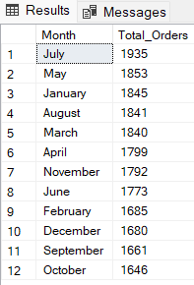

**3. Percentage of Sales by Pizza Category**

SELECT pizza_category, SUM(total_price) AS Total_Sales, SUM(total_price) * 100 / (SELECT SUM(total_price) FROM pizza_sales) AS PCT

FROM pizza_sales

GROUP BY pizza_category

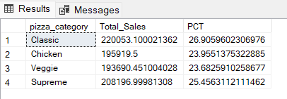

If wanted to use Filter, where want to view the percentage of month of January, use WHERE Clause.

SELECT pizza_category, SUM(total_price) AS Total_Sales, SUM(total_price) * 100 / (SELECT SUM(total_price) FROM pizza_sales WHERE MONTH(order_date) = 1) AS PCT

FROM pizza_sales

WHERE MONTH(order_date) = 1

GROUP BY pizza_category

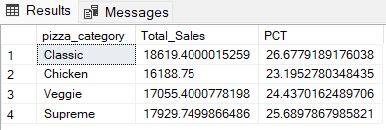

**4. Percentage of Sales by Pizza Size**

SELECT pizza_size, CAST(SUM(total_price) AS DECIMAL (10,2)) AS Total_Sales, CAST(SUM(total_price) * 100 / (SELECT SUM(total_price) FROM pizza_sales) AS DECIMAL (10,2)) AS PCT

FROM pizza_sales

GROUP BY pizza_size

ORDER BY PCT DESC

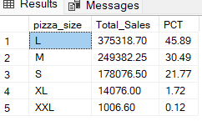

SELECT pizza_size, CAST(SUM(total_price) AS DECIMAL (10,2)) AS Total_Sales, CAST(SUM(total_price) * 100 / (SELECT SUM(total_price) FROM pizza_sales WHERE DATEPART(QUARTER, order_date) =1) AS DECIMAL (10,2)) AS PCT

FROM pizza_sales

WHERE DATEPART(QUARTER, order_date) = 1

GROUP BY pizza_size

ORDER BY PCT DESC

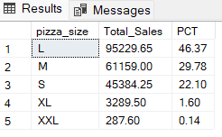

Always use the WHERE Clause before GROUP BY and After the FROM Function.

**5. Total Pizza Sold by Pizza Category & Size**

SELECT pizza_category, pizza_size, SUM(quantity) AS Total_Sales FROM pizza_sales

GROUP BY pizza_category, pizza_size

ORDER BY Total_Sales DESC

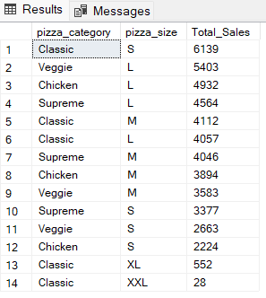

**6. Top 5 Pizza by Revenue**

SELECT TOP 5 pizza_name, SUM(total_price) AS Total_Revenue FROM pizza_sales

GROUP BY pizza_name

ORDER BY Total_Revenue DESC

Always add GROUP BY function when using Aggregation for Categorical Variables.

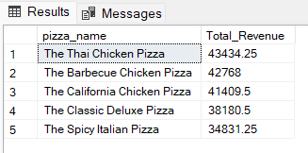

**7. Bottom 5 Pizza by Revenue**

SELECT TOP 5 pizza_name, CAST (SUM(total_price) AS DECIMAL (10,2))AS Total_Revenue FROM pizza_sales

GROUP BY pizza_name

ORDER BY Total_Revenue ASC

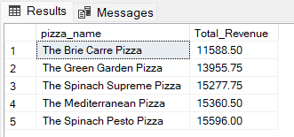

**8. Top 5 Pizzas by Quantity**

SELECT TOP 5 pizza_name, SUM(quantity) AS Quantity FROM pizza_sales

GROUP BY pizza_name

ORDER BY Quantity DESC

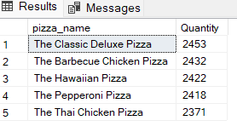

**9. Bottom 5 Pizzas by Quantity**

SELECT TOP 5 pizza_name, SUM(quantity) AS Quantity FROM pizza_sales

GROUP BY pizza_name

ORDER BY Quantity ASC

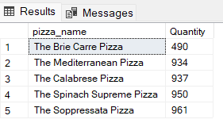

**10. Top 5 Pizzas by Orders**

SELECT TOP 5 pizza_name, COUNT(DISTINCT order_id) AS Total_Orders FROM pizza_sales

GROUP BY pizza_name

ORDER BY Total_Orders DESC

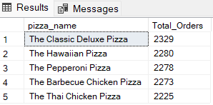

**11. Bottom 5 Pizzas by Orders**

SELECT TOP 5 pizza_name, COUNT(DISTINCT order_id) AS Total_Orders FROM pizza_sales

GROUP BY pizza_name

ORDER BY Total_Orders ASC

